How Globalization-Slavery Put Tasteless Tomatoes on your Table?
David M. Boje, Keynote, Global Management Conference
June 8, 2017 at Lille France 12:30-2PM
I am an ontologist. An ontologist does storytelling about the social and material situation of global slavery. I do sociomaterial storytelling of the relational processes at a macro-systemic level. The global problem is that slavery in globalization is an ‘untold story!’
Modern, agribusiness tomato is tough, plasticine, perfectly round, perfectly red, and identical, as if stamped out by a machine so it can be picked by the industrial-scale factory farming. According to Estabrook (2012), these tomatoes are bereft of nutrition and taste (30% less Vitamin C and thiamin, 19% less niacin, 62% less calcium, and 14 times as much sodium, than counterparts in 1960s).
Modern-day slavery accompanies globalization. It has always been so. Globalized slavery is an international network of economic systems (Bales, 2012). The labor markets for slavery are a result of neoliberal globalization whose ‘free and open markets’ carries dire consequences for us all. I propose worker-driven global capitalism as a way to tame the greed of neoliberal globalizing. Neoliberal capitalism is without any ethical standards, and is causing human and ecological destruction. It increases the gap between the rich and the poor, concentrating wealth in the elite 1 percent. It is time to stop privileging the rights of investors in corporations that permit slavery in their global supply chains. There is success in ending modern-day slavery, when worker-driven initiatives are enacted. It begins with putting people ahead of corporations.
Tov Assogvavi has proposed Globalization P³as a way forward.
Globalization P³: People, Prosperity & Posterity
Globalization P³ invokes the image of a world of People interconnected in the collaborative enterprise of creating Prosperity today yet sustainable for Posterity. People first as the engines of globalization (for the welfare of people), Prosperity as an immediate impact for all, and sustainability as the cornerstone for a better Posterity. Posterity means the children of your children should be the consideration.
Can we treat people as persons instead of ‘human resources’ to be managed (Fortier & Albert, 2015)? “They are often managed like purely material resources that can be bought, sold, modified, or discarded after use” (p. 1). Modern-day slavery is a one-dimension conception of human beings as ‘disposable,’ ‘objects,’ ‘factors of production,’ or ‘an instrument’. Fortier and Albert (2015: 4) recommend ‘persons management’ instead of reductionist ‘human resource management’ (HRM): “It appears that, in its actual form, HRM is incapable of enabling the full expression of human capabilities, whence the importance of evolving toward persons management.” Globalization P³ is not HRM! Fortier and Albert (2015: 5) recommend Morin’s dialogical approach:
“… the complex unity that exists between two logics, entities, or instances, that are complementary, concurrent and antagonistic, and which feed on one another, cooperate, but are also in opposition and battle each other. In dialogic, the oppositional forces remain and constitute complex entities or phenomena (there is no synthesis, which is the expected result in classical dialectic). (Morin, 2001, p. 281)
Globalization P³ is also not the usual Triple Bottom Line (3BL) where profit is the only bottom line (Elkington, 2004).

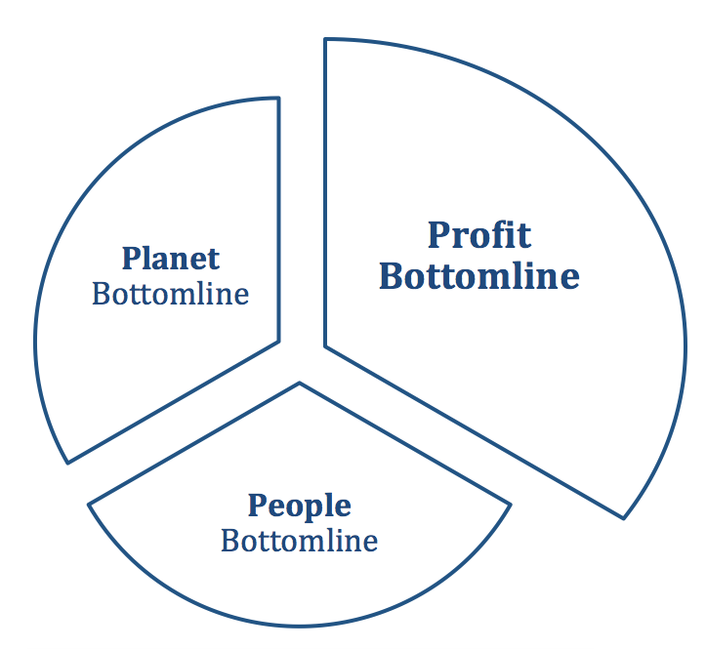
Figure 1: Triple Bottom Line Model (image by Boje, used by permission)
Triple Bottom Line advocates never actually propose how to measure the ADDITION of profit bottom line + People bottom line + Planet bottom line. Without an agreed methodology, the income statement trumps the people and planet measurement. Norman and MacDonald (2004: 53) put it this way,
“We submit that the only way to make sense of such a claim is by formulating it (roughly) in the way we have with the Aggregation Claim, above. That is, we cannot see how it could make sense to talk about a bottom line analogous to the bottom line of the income statement unless there is an agreed-upon methodology that allows us, at least in principle, to add and subtract various data until we arrive at a net sum.”

Worker-Driven Global Capitalism (P³⁾ is something new on the global scene. It is a combination of ensemble leadership (with workers in leadership in collaboration with consumers), a people-first (worker-driven) capitalism rather than corporate-driven capitalism, and animated system where people (consumers & workers) create systems to empower themselves, to build their capacity for power-with other rather than power-over others, as is the case in hierarchical to-down approaches.
“Over one thousand men and women had been forced to work against their will in the fields of Florida. Most slavery goes unreported… Workers were ‘sold’ to crew bosses to pay off bogus debts, beaten if they didn’t feel like working or were to sick or weak to work, held in chains, pistol whipped, locked at night into shacks in chain-link enclosures patrolled by armed guards… “Corpses of murdered farm-workers were not an uncommon sight in the rivers and canals of South Florida” (Estabrook, 2012: xix).
Slavery is tolerated and ignored in Florida. The Thirteenth Amendment of the United States Constitution is the right to be free from involuntary servitude, slavery and human trafficking. When the slavery involves undocumented workers, there are many hurdled to prosecution (Estabrook, 2002: 80). “In a strange country where they understand neither the language nor the law, workers are reluctant to come forward” (IBID., p. 80). In their home country cops are often thugs in uniform. Without green cards, there is the risk of deportation.
“Pesticides, so toxic to humans and so bad for the environment that they are banned outright for most crops, are routinely sprayed on virtually every Florida tomato field, and in many cases, sprayed directly on workers, despite federally mandated periods when fields are supposed to remain empty after chemical application” (Estabrook, 2012: xx).
Sienna Baskin, an attorney with the advocacy initiative Sex Workers Project-relation between the trafficking epidemic and immigration and law enforcement policies that criminalize victims:
A highly punitive and restrictive immigration system is a factor that leads people to take risks in migrating, sometimes ending up trafficked, although we must also look at poverty, persecution and gender inequities as factors. The growing problem of labor exploitation could be lessened by comprehensive immigration reform that provides visas and fair wages to all workers.

Victims often do not tell their story of slavery because they fear the consequences of attempting escape for their family members. They depend on their slave bosses for their livelihoods and to protect against from immigration authorities if they are undocumented. Temporary worker visas may actually facilitate the global slave trade.
This is what I propose. Three inter-related worker-driven initiatives.

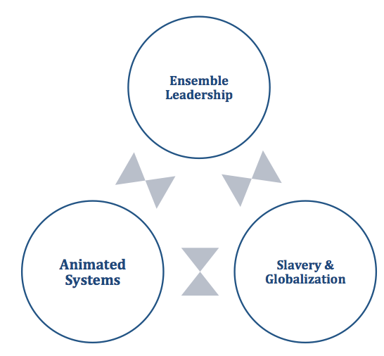
Figure 1 –Ensemble, Systems, and Slavery & GLobalization (Boje, original, Jun 5, 2017, used by permission).
In modern-day slavery, worker-driven global capitalism is a way to transform the situation. The history of the Coalition of Immokalee Workers (CIW) is a history of workers.
“We are the Earth and our roots began in Florida… We are a strong root, a root not even the corporations that exploit workers will be able to pull from the ground”, says Lupe, a CIW worker (March 7, 2016).

In 1996, a foreman struck a Immokalee worker, who had stopped work to get a drink of water. Proyecto called for a march to the house of the contractor, chanting ‘Golpear a uno de nosotros es golpear a todos’–‘a blow to one of us is a blow to us all’ (Bell, 1995; Bowe, 2007). This event marked the official founding of CIW, and the beginning of its ‘Anti-Slavery Campaign” and practices of debt bondage, intimidation, beatings, pistol-whippings, etc. The “Awareness _ Commitment = Change’ campaign aimed at negotiating collective bargaining. Lucas Benitez tells the founding story of CIW:

“When we started CIW. started with farm workers, and I saw and suffered first hand and how they suffered these abuses. I saw sexual harassment for women, which is the daily bread for thousands of women working in the field, physical abuse, verbal abuse and sometimes you work three or four days, and when you try to recover you money, you never receive your payment. So when we started CIW, in the first year, when we started our work, we recovered more than $100,000 in ahh back wages. So, this is the rule physical abuse, verbal abuse, sexual harassment, and in extreme cases slavery, a real slavery. And this ahh We work very close with Federal Department of Justice, the Civil Rights Division, to investigate and prosecute seven cases. And we liberate more than a thousand works in a real slavery in the US. So, we came from there. And we started to organize … and … by ourselves. Because we saw the situation. We needed to see a change, change in the balance of power between farm workers and growers. Because in Florida the majors are the big agri-industry, not family farms.”

The campaign spread nationwide as they defend the rights they have won. 14 corporations have signed the Fair Food Program (FFP) agreement. They pledge to keep marching and fighting until Wendy’s signs an agreement.

"The bosses carried weapons. They scared me. I never knew where I was. We were transported every fifteen days to different cities. I knew if I tried to escape I would not get far because everything was unfamiliar. The bosses said that if we escaped they would get their money from our families."
--Congressional testimony of Maria, trafficking survivor from Mexico
This is not someone else’s problem. Once we are aware of modern-day slavery, it is our ethical answerability to intervene, to create a worker-driven global practice of opposition to slavery, human trafficking, and all the accompanying abuses.
“Though the government has documented major strides since the enactment of the Trafficking Victims Protection Act of 2000, this year's report continues to gloss over the systemic failures that underwrite the bottomless thirst for cheap labor-or even better, free labor”

December 12, 1999 CIW organized a general strike followed in a few months by a 230-mile ‘March for Dignity, Dialogue and a Living wage’ from Fort Myers to the Orlando offices of Florida Fruit and Vegetable Association (Bohorquez-Montoya, 2003). \In 2001, CIW organized the first ‘Taco Bell Truth Tour’ a trek of 8,000 miles form Southwest Florida to Taco Bell headquarters in Irvine, California. This began the international boycott of Taco Bell in the world economy. The second ‘Taco Bell Truth Tour’ (28 Feb and 16 Mar, 2002) about 90 participants travelled form Florida to Irvine, where 2000 people joined the marchers. In Fall 2003 the Taco Bell campaign reached Ecuador.
Example: Institutional racism in Food Industry occurs within and between institutions: growers, corporate supply chains such as fast food outlets, big box stores, super markets. Female farmhands also often face sexual assault and harassment in the fields, but do not report the crime for fear of retaliation.
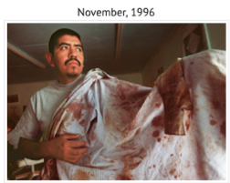
The shirt on the left belonged to a young man who walked into the CIW’s office in November 1996. He had been picking tomatoes in a field near Immokalee when he stopped to take a drink of water. A field supervisor accosted him, shouted, “Are you here to work, or to drink water?” and launched into him, leaving him badly bruised and bloodied — and determined to find justice. The young worker walked back to Immokalee, headed straight to the CIW office, and sparked a nighttime march of nearly 500 workers on the crew leader’s house. The marchers brandished his shirt as a banner, declaring, “If you beat one of us, you beat us all!“ and helped launch a movement that changed Immokalee forever.

What is the Situation of Farmworkers in the Global Supply Chains?

- Slavery in most extreme situation
- Wage-cheating in usual situation
- Sexual assault/rape/abuse in many situations
- Physical abuse in too many situations
- Peon – payment schemes rampant situation
- Racism is corporate supply chains in supper market & fast food industry
- Consumers blind to racist working condition situation of corporate supply chains in food industry
Lucas Benitez (recorded by me March 25, 2017, at Ohio State University):

““We’ve just heard from the Police of Dublin that Wendy’s security has said that they don’t want any of us on their property. What that means is that they are scared. Because if you have nothing to hide, you can feel free to let people onto your property. But once again, Wendy’s is trying to hide behind its security and behind the police. But no matter what, we have the right to be on public property in front of their headquarters, and that is where we will go.”

To which Lupe added (recorded by me March 25, 2017, at Ohio State University):

“Perhaps Wendy’s can say that we aren’t allowed on their property, but really, we’re inviting them onto our land — our land of human rights, our land of respect. We’re going to say to Wendy’s, come to us, here is where the truth is… you cannot ignore reality any longer.”

This is a study of ‘ensemble leadership theory’ (Rosile, Boje, & Nez, 2016) initiated by the Coalition of Immokalee Workers (CIW http://www.ciw-online.org/) ‘we are all leaders’ initiative to form partnerships since 1996 with people of faith (Interfaith Worker Justice (http://www.iwj.org/resources/2016-hanukkah-reflections/first-night-of-hanukkah) and university student organizations, such as Student/Farmworker Alliance (http://www.sfalliance.org/), national network of students and young people organizing with CIW to uproot exploitation in the fields and build a food system based on justice, respect and dignity for farmworkers.
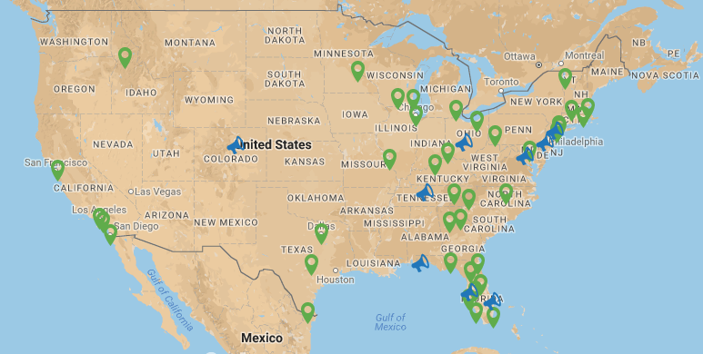

Figure 1: Locations of Student/Farmworker Alliance Chapters in U.S. (source: http://www.sfalliance.org/contact/)

In the words of an Immokalee farmworker, we heard, standing in the pouring rain in Columbus Ohio on March 26, 2017:

“For many years now, farmworkers from Florida, people of faith, students, have been preparing the Earth so we can plant it with a seed of hope. Together we have been able to plant a seed that has flourished and given life to the Fair Food Program. But, Wendy’s instead of joining this program continues to spray their poison on our plant, full of good fruit. They keep saying they have a Code of Conduct, but as long as workers’ voices are excluded from that Code, it means nothing. All of us are prepared to defend all that we have won because we do not want to return to an era of abuse, because we do not want to return to an era of exploitation, we want to continue to live with freedom and dignity” (witnessed March 26, 2017, https://vimeo.com/210302084, accessed March 28, 2017).

As a human rights investigator in the Fair Food Program puts it:

“For generations, farm work has been one of the lowest paid, most dangerous, and least protected jobs in the country. Farmworkers have historically faced human rights abuses in the field such as sexual violence, perilous conditions, and in the most extreme cases, forced labor. The Coalition of Immokalee Workers is a human rights organization that is rewriting this history through its Fair Food Program, a groundbreaking model of social responsibility that is based on a unique partnership among farmworkers, consumers, growers, and major retail brands. Our goal is to eliminate human rights abuses across the nation and beyond… Hundreds of thousands of women and men who work in corporate supply chains still face horrific conditions and that must change. In the 21st century the U.S. must have humane and modern supply chains” (https://vimeo.com/185231307, accessed March 28, 2017).

How do we as ‘ensemble’ leaders identify structural racism?
The key indicators of structural racism are inequalities in power, access, opportunities, treatment, and policy impacts and outcomes, whether they are intentional or not. Structural racism is more difficult to locate in a particular institution because it involves the reinforcing effects of multiple institutions and cultural norms, past and present, continually producing new, and re-producing old forms of racism.
Students in over 300 universities across the U.S. began boycotting Taco Bell, with a ‘Boot the Bell’ campaign in support of Immokalee tomato field forkers in Florida. The carnivalesque spirit of anti-globalization events resulted in closing over 20 Taco Bell outlets on U.S. campuses. “In another five campuses, all Taco Bell products were removed, and in a further five, Taco Bell franchises were prevented from opening altogether” (Drainville, 2008: 363).

In May 2004, to ease tensions, Taco Bell made an unsolicited check of $110,00 to CIW. CIW returned the check, calling it a public relations stunt. “In that period, Lucas Benıtez, spokesperson of the Coalition since 1996, has also emerged as something of a symbolic figure in the United States; a Guevara, Chavez, or Marcos-like poster boy of resistance” (Drainville, 2008: 362).
“In November 1998, the US Catholic Bishops’ Conference honored Benıtez with the Cardinal Bernardin Award for New Leadership for his ‘leadership in efforts to eliminate poverty and injustice in contemporary society’. In October 1999, Rolling Stone magazine and Do Something—a New York based non-profit ‘youth leadership organization’—gave him its $110,000 Brick Award Grand Prize as ‘America’s Best Young Community Leader’. CIW helped to “document cases built by prosecutors of the Civil Rights Division of the Department of Justice against multistate slavery operations based in Florida” (Drianville, 2008: 363)
Over a period of 23 years, CIW brought 14 corporations into the Fair Food Program, and ended slavery practices in those supply chains.

- WORKER-DRIVEN ENSEMBLE LEADERSHIP: Ensemble in French means 'together'. Rosile, Grace Ann; Boje, David M.; Nez, Carma Claw. (2016). “Ensemble Leadership Theory: Collectivist, Relational, and Heterarchical Roots from Indigenous Contexts.” Leadership journal. CLICK HERE for online prepublication draft, or here for PDF from Sage. CIW practice is 'everyone is a leader'. Ensemble leadership builds an alliance of self-managing groups. CIW's worker-driven alliances consists of network of these five groups:
  - Coalition of Immokalee Workers(CIW) does worker education, animates workers
  - Inter-Faith Alliance for Fair Food (AFF)
  - Student/Farmworker Alliance (SFA) organizing colleges and universities
  - Fair Food Standards Council (FFSC) doing audits and monitoring sustainable agricultural industry to advance human rights of farm workers, and certify 'fair food' tomato growing and worker practices in Florida, Georgia, North and South Carolina, Virginia, Maryland and New Jersey.
  - Fair Food Program (FFP) has a Code of Conduct in an alliance of consumers, 17 growers, and 14 Buyers/brands (Ahold USA, Aramark, Bon Appetit Management CO., Burger King, Chipotle Mexican grill, Compass Group, The Fresh Market, McDonald's, Sodexo, Subway, Trader Joe's, Wal-Mart, Whole Foods Market, and Yum Brands [Taco Bell, KFC, Pizza Hut, & WingStreet worldwide].
- WORKER-DRIVEN ANIMATED SYSTEMS: “We don’t organize… we animate people” – Lucas Benitez (interview in Immokalee Florida at CIW). Animation means creating spaces for people to empower themselves, to light the fire within, to create power-with as an alternative to power-over hierarchical domination that is top-down system (Mary Parker Follett's terms; Stout, M., & Staton, C. M. (2011). The ontology of process philosophy in Follett's administrative theory. Administrative Theory & Praxis, 33(2), 268-292.). Animated systems theory is an alternative to 'representational' abstract systems theory. Rather than abstraction, animated systems theory is focused on embodied practices, animated processes in actions. It begins with conversations that are dialogical, not with checklist interview methods, and definitely not with 1st, 2nd, or 3rd wave Grounded Theory positivism. It is implemented in audit-->reports-->corrective action plan (See FFSC above).
  - Boje, D. M. (2016) SLIDES SEAM’s ‘Storytelling Dialectical Method’ and the Failure of Appreciative Inquiry as a Scientific Method of Organizational Development and Change June 8 ODC Lyon Presentation Here is the paper for this event
  - Key to Animated Systems is this CIW formula:
This is the saying of Coalition of Immokalee Workers (CIW), a group implementing work-driven social responsibility.
CIW uses Worker and Consumer education to raise 'Consciousness' + 'Commitment' to move from bystander spectator role to intervention in once-occurrent event-ness of Being-in-the-world together = 'Change' in the system of modern-day slavery in agriculture.
- WORKER-DRIVEN GLOBAL CAPITALISM: For centuries slavery has been the outcome of 'managerialist' global capitalism. Management practices began with slavery, and have continued into modern times, especially in agriculture. Using worker education, worker-driven alliances, system of market-driven model of accountability in alliance of consumers, brands, growers, and workers creates revolutionary changes in global socioeconomic practices of global capitalism that are ending slavery practices and promoting Fair Food Program practices. See Kevin Bale's work on 'old' and 'new' slavery in the world. Old slavery required a contract and was very extensive. New slavery has no contract. When you are done with the slaves, you dispose of them, and get new slaves when needed.
If we look at kinds of 'Relational Process Ontologies' we can apply to Modern-day Slavery in USA, there are several situations to consider on the farm:
- Farm A - gets its farmworkers from across the New Mexico border, in Texas, pays a crew boss, and the crew boss pays the farmworkers less than minimum wage of the state (or less than the going piece rate). This is situation in New Mexico.
- Farm B - gets its farmworkers using a special Visa that allows immigrants only to work on that one farm or not at all. This is situation in many states.
- Farm C - uses a Coyote to smuggle immigrant workers across boarder from Mexico, Guatemala, and other countries, promising them jobs, many of the women are diverted and sold into sex labor, and most males are sold for work on agricultural farms, etc. The crew boss contracts with land owner to provide labor force, under the most miserable working and slavery conditions, including workers in the field while concoctions of dangerous (and some deadly) pesticides and herbicides are sprayed (resulting in birth defects, cancer, and so on). This was situation in Florida before CIW.
- Farm D - uses a local network, such as someone who assembles available local farmworkers to go to a particular farm to plant and or harvest. This is current situation in New Mexico.
- Farm E - uses Coalition of Immokalee Workers (CIW), contracting directly, and uses Fair Food Program (FFP) code of conduct in alliance of 17 growers and 14 brands to enact monitoring in worker-driven program of corporate social responsibility administered by the Fair Food Standards Council that processed and resolved 1,700 complaints, some in favor of workers, others in favor of growers. Farmworkers have a clock in in and clock out system to track hours (some crops also use coin-tokens per basket; workers paid bonuses). This relational process system is in seven eastern states.

What is an Ensemble? In French, Ensemble means ‘together.’ Together people lead. You are familiar with an ensemble of musicians playing jazz, an ensemble of dancers performing together, an ensemble of singers without a script, and an ensemble of actors bringing about a unified effect in ‘Ensemble Theater’ by using improvisation. These all involve improvisation to achieve a unity of effect without relying upon single leader, such as orchestra leader, choreographer, or theater director. I believe we can extend ‘Ensemble leadership’ (Rosile, Boje, & Nez, 2016) into what I would like to call ‘Ensemble Global Capitalism.’
How can we do this? We can engage in ensemble democracy, ensemble entrepreneurship, and use ensemble storytelling, and ensemble theater (that combines dance, music, song, storytelling) improvisation that are tools necessary to resist the latest wave of global empire, in its modern-day slavery.
Worker education,
Worker-driven alliances, &
System of alliance of consumers, brands, growers, and workers
This creates revolutionary changes

References

Bales, Kevin (2012). Disposable People: New Slavery in the Global Economy. University of California Press. ISBN 978-0520272910.

Chun, C. W. (2009). Contesting neoliberal discourses in EAP: Critical praxis in an IEP classroom. Journal of English for Academic Purposes, 8(2), 111-120.

Elkington, John. Enter the triple bottom line. The triple bottom line: Does it all add up, 2004, vol. 11, no 12, p. 1-16.

Glassman, R. (2016). Caring Capitalism: A New Middle Class Base for the Welfare State. Springer.

Klein, N. (2007a). Disaster capitalism. Harper’s Magazine, 315, 47-58.

Klein, N. (2007b). The shock doctrine: The rise of disaster capitalism. Macmillan.

Omi, M., & Winant, H. (2014). Racial formation in the United States. Routledge.

Piketty, T. (2014). Capital in the twenty-first century. Belknap Press.

Vrasti, W. (2011). " Caring" Capitalism and the Duplicity of Critique. Theory & Event, 14(4).

Wright, C., & Nyberg, D. (2015). Climate Change, Capitalism, and Corporations: Processes of Creative Self-destruction. Cambridge University Press.

MORE References

Follett, M. P. (1898). The Speaker of the House of Representatives. Longmans, Green & Co. NY, NY.

Follett, M. P., & Hart, A. B. (1902). The Speaker of the House of Representatives with an Introduction by AB Hart. Longmans, Green, & Company.

Follett, M. P. (1918). The New State: Group organization the solution of popular government. University Park, PN: Penn State Press.

Follett, M. P. (1919). Community is a process. The Philosophical Review, 28(6), 576-588.

Follett, M. P. (1924/1930). Creative Experience. Рипол Классик; NY/London: Longmans, Green and Co. on line at http://ww.pqm-online.com/assets/files/lib/books/follett.pdf

Follett, M. P. (1926). The giving of orders. Scientific foundations of business administration, 156-162.
Follett, M. P. (1941). Dynamic Administration: The Collected Papers of Mary Parker Follett, edited by Metcalf, H. C., & Urwick, L. F. NY/London: Harper and Brothers.

Follett, M.P. (1949.1987). Freedom and Co-ordination. Lectures in Business Organization. Edited, with an Introduction by L. Urwick. NY/London: Garland Publishing.

Fortier, Michel; Albert Marie-Noëlle. (2015). From Resource to Human Being: Toward Persons Management. SAGE Open, 2015, vol. 5, no 3, pp. 1-13. 2158244015604347.

Norman, Wayne et MacDonald, Chris. (2004). Getting to the bottom of “triple bottom line”. Business Ethics Quarterly, vol. 14, no 02, p. 243-262.

Omi, M., & Winant, H. (2014). Racial formation in the United States. 3rd Edition. NY/Oxon: Routledge.

Rosile, Grace Ann; Boje, David M.; Nez, Carma Claw. (2016). “Ensemble Leadership Theory: Collectivist, Relational, and Heterarchical Roots from Indigenous Contexts.” Leadership journal. CLICK HERE for online PDF

Common Dreams June 6 2017. https://www.commondreams.org/views/2010/06/19/driven-globalization-todays-slave-trade-thrives-home-and-abroad Accessed June 7, 2017
https://www.youtube.com/watch?v=jyTFiCzv1_g accessed Jun 6, 2017
Campaign for Fair Food and the Fair Food Program, INTERVIEW WITH LUCAS BENITEZ http://www.ciw-online.org/blog/2016/10/james-beard-leadership-award/ Accessed June 7, 2917
http://www.protectionproject.org/sites/default/files/file/activities/tacap/US/trafficking/survivor_maria.pdf accessed June 7, 2017; see https://www.commondreams.org/views/2010/06/19/driven-globalization-todays-slave-trade-thrives-home-and-abroad for more on this topic
http://www.state.gov/g/tip/rls/tiprpt/2010/142765.htm accessed June 7, 2017
Photo and quotes in this paragraph from http://www.ciw-online.org/blog/2012/03/not_1996_anymore/ accessed April 1, 2017 (Will seek permission to use photo).

